

**Survey Project**

**Advanced Mobile Application Development**

**Fall 2016**

**Homework 1**

**Mobile Application:**

**Programming Language: iOS – Swift**

1. **Log In Screen**: Patient logs in to the screen with the credentials. The credentials are verified with the server and the patient is authenticated after verifying with the token from the server.
2. **Questions Screen:** The questions relevant to the patient are displayed on the screen and the patient is asked to record the responses and the responses are posted back to the server for the doctor to view the results on the web-portal.

**MYSQL**

We are using two tables Patients and Patient Response

**Patient:** It stores all the relevant patients details and the schema is described below

|  |  |  |  |  |  |
| --- | --- | --- | --- | --- | --- |
| Field | Type | Null | Key | Default | Extra |
| username | varchar(45) | NO | PRI | NULL |  |
| passw | varchar(45) | NO |  | NULL |  |
| name | varchar(45) | YES |  | NULL |  |
| gender | varchar(45) | YES |  | NULL |  |
| age | int(11) | YES |  | NULL |  |

**Patient Response:** It stores the patients response to be survey and the schema is described below

|  |  |  |  |  |  |
| --- | --- | --- | --- | --- | --- |
| Field | Type | Null | Key | Default | Extra |
| rID | int(6) unsigned | NO | PRI | NULL | auto_increment |
| username | varchar(45) | NO | MUL | NULL |  |
| r1 | int(2) | YES |  | NULL |  |
| r2 | int(2) | YES |  | NULL |  |
| r3 | int(2) | YES |  | NULL |  |
| r4 | int(2) | YES |  | NULL |  |
| r5 | int(2) | YES |  | NULL |  |
| r6 | int(2) | YES |  | NULL |  |
| r7 | int(2) | YES |  | NULL |  |
| r8 | int(2) | YES |  | NULL |  |
| r9 | int(2) | YES |  | NULL |  |
| r10 | int(2) | YES |  | NULL |  |
| r11 | int(2) | YES |  | NULL |  |
| r12 | int(2) | YES |  | NULL |  |
| r13 | int(2) | YES |  | NULL |  |
| r14 | int(2) | YES |  | NULL |  |
| r15 | int(2) | YES |  | NULL |  |
| r16 | int(2) | YES |  | NULL |  |
| r17 | int(2) | YES |  | NULL |  |
| r18 | int(2) | YES |  | NULL |  |
| r19 | int(2) | YES |  | NULL |  |
| r20 | int(2) | YES |  | NULL |  |
| r21 | int(2) | YES |  | NULL |  |
| r22 | int(2) | YES |  | NULL |  |
| r23 | int(2) | YES |  | NULL |  |
| r24 | int(2) | YES |  | NULL |  |
| r25 | int(2) | YES |  | NULL |  |
| r26 | int(2) | YES |  | NULL |  |
| r27 | int(2) | YES |  | NULL |  |
| r28 | int(2) | YES |  | NULL |  |
| r29 | int(2) | YES |  | NULL |  |
| r30 | int(2) | YES |  | NULL |  |
| r31 | int(2) | YES |  | NULL |  |
| r32 | int(10) | YES |  | NULL |  |
| r33 | int(10) | YES |  | NULL |  |
| Medication | int(3) | YES |  | NULL |  |
| Diet | int(3) | YES |  | NULL |  |
| PhysicalActivity | int(3) | YES |  | NULL |  |
| Smoking | int(3) | YES |  | NULL |  |
| WeightManagement | int(3) | YES |  | NULL |  |
| Alcohol | int(10) | YES |  | NULL |  |
| Medication_check | int(3) | YES |  | NULL |  |
| Medication_result | varchar(25) | YES |  | NULL |  |
| Dite_result | varchar(25) | YES |  | NULL |  |
| PhysicalActivity_result | varchar(25) | YES |  | NULL |  |
| Smoking_result | varchar(25) | YES |  | NULL |  |
| WeightManagement_result | varchar(25) | YES |  | NULL |  |
| Alcohol_result | varchar(25) | YES |  | NULL |  |

**Server Side**

* The server app should include a web site portal and web apis.

The server side programming has been performed in NodeJS and ExpressJS. The server would serve the below functionalities:

* The *register* page to register new patients. If the username already exists, then the page is refreshed. Need to handle the user exists from UI.
* The *allpatients* page would give out a JSON with all the patients details which is parsed and viewed to admin index page.
  + {"username":"pawanaraballi","passw":"12345","name":"i","gender":"Male","age":12}
* The *patientspage* page is used to record the response from the survey. The appropriate survey page response will be recorded and stored in the table. The below is the json structure in which the data has to be sent form Mobile.
  + {

"username" : "pawanaraballi",

"check" : 0,

"r1" : 5,

"r2" : 7,

"r3" : 7,

"r4" : 2,

"r5" : 2,

"r6" : 2,

"r7" : 2,

"r8" : 2,

"r9": 2,

"r10" : 3,

"r11" : 2,

"r12" : 2,

"r13" : 2,"r16" : 2,"r17" : 2,

"r14" : 2,"r15" :2,"r18" : 2,"r19" : 2,

"r20" : 2,"r21" : 2,"r22" : 2,

"r26" : 2,"r25" : 2,"r24" : 2,"r23" : 2,

"r27": 2,"r28" : 2,"r29" : 2,

"r30" : 2,"r31" : 2,"r32" : 6,"r33" : 5

}

* The tokenization using JWT has been implemented.

**Web**

The Admin is allowed to create new patients. The basic information has to be provided for new patient addition. The details which has to be provided are Name, Username, Gender, Age and Password. There is basic error handling which is performed in the UI like the age number restricted to two digits.

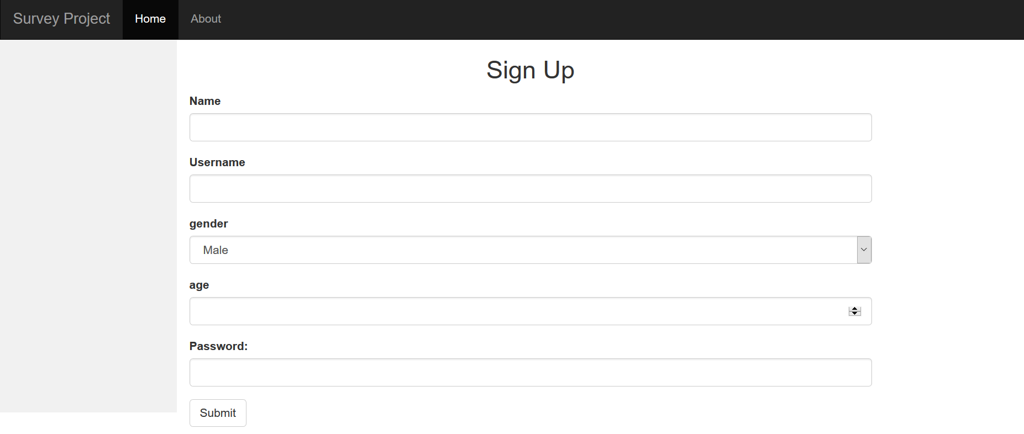

The list of patients is displayed using the Datatables jquery library. This list of patients will be displayed in the home page of the website.

